**CR (Computed Radiography) Image Plate**

**Test Report**

|  |  |  |  |
| --- | --- | --- | --- |
| Approval | Drawing | Check by | Approval |
|  |  |  |
|  |  |  |

**DIGIRAY Corp.**



Contents

1. Thermal Properties and Chemical Analysis Request Form 3

# **Thermal Properties and Chemical Analysis Request Form**

|  |  |  |  |  |  |
| --- | --- | --- | --- | --- | --- |
| **Analysis requester** | **Digiray Co. Ltd.** | **Request** | **연구소** | **업 무 번 호** | **20-FILM-003** |
| **Date** | **2021. 02. 04** | **Result** | **2021. 02. 15** | **분 석 수 행 자** | **PTATR** |
| **Title** | **[21-FILM-003] CR(Computed Radiograph) Film 조성 분석 (2종)** | | | | |



|  |  |  |
| --- | --- | --- |
| **MFI (MP-1200), Spectrophotometer (M-3700A)** | | **MFI (Temp [ ] Load [ ]) Colorimeter ( L,a,b [ ] YI [ ])** |
| **Thermal Analyzer (DSC-2500, DSC-204, TGA-5500,**  **TG-209, STAR DSC-1, STAR TGA-1)** | | **DSC [ ] TGA [ ] TMA [ ]** |
| **Thermal Analyzer (TGA-IR, TGA-MS)** | | **TGA-IR(Nicolet 6700) [ ] TGA-MS(GSD-320T2) [ ]** |
| **WD-XRF (ZETIUM) / ED-XRF (Oribis)** | | **Mineral Filler [**  **] Additive [ ] Metal Elements [ ] RoHS [ ]** |
| **FT-IR (Nicolet 6700) / PIKE (상온 Press)**  **Detector (MCTA, MCTB, DTGS)** | | **ATR [**  **] Normal Spectrum [ ] Ethylene Contents [ ] Liquid Transmission [ ] TQ 정량 [ ]** |
| **GC (FID7890A, 7890B) / GC (Head Space G1888)**  **GC-MS (TDS 5975B) / GC-MS (5973)**  **HPLC (LC-800) / UPLC / LC-MSMS** | | **유기화합물 시료의 성분 [ ] Total Emission Content [ ]**  **TVOC Content [ ] Liquid 성분 [ ]**  **비-휘발성 시료의 성분 [ 정성 ( ) 정량 ( ) ]** |
| **GPC_IR (VISCOTEK, PL220C) / CRISTAF-TREF** | | **평균분자량(분포) [ 상온 ( ) 고온 ( ) ] / SF Area [ ]** |
| **Auto Xylene Soluble Tester (CRYSTEX QC)** | | **Ethylene Contents [ ] XS [ ] SF [ ]** |
| **ICP (Optima 5300DV) / EA (FLASH 2000)** | | **무기 금속 원소 [ ] / C,H,N,S [ ] O [ ] C,N [ ]** |
| **PSA (HORIBA,LA-960) / Nano PSA (Zeta Sizer)** | | **Material [ ] Expert Size [ ]㎛ [ ]nm** |
| **Capillary Rheometer (RH-2000)** | | **Material [ ] 측정온도범위 [ ]℃** |
| **ARES (tilting Rheometer)** | | **Material [ ] 측정온도범위 [ ]℃ Property [ ]** |
| **XRF, GC Pretreatments (ATLAS, BUCHI)** | | **Glass Bead [ ] Extraction [ ] Grinding [ ]** |
| **형태**  **분석** | **SEM (Quanta 250 FEG) / EDS (Apollo XP)** | **표면[ ] 단면 [**  **] / Expert Element [ ] 조성분석 [**  **]** |
| **Mini SEM (Phenom XL) / XRD(X’Pert Pro)** | | **표면[ ] 단면 [ ] / Expert Element [ ] 조성분석 [ ]**  **Material [ ] Conventional XRD Range (θ-2θ Mode) [ ]** |
| **Raman Spectrometer (Flex G)** | | **Material [**  **] Laser Source [ 785nm ( ), 532nm (**  **), UV ( ) ]** |
| **촉매**  **분석** | **BET (ASAP 2020)** | **Material [ ] Degas degree [ ]** |
| **TPD, TPR, TPO (Autochem 2920)** | | **Material [ ] Pre-treatment degree [ ] Mix gas [ ]** |
| **Pulse Chemisorptions (Autochem 2920)** | | **Material [ ] Pre-treatment degree [ ] Metal weight [ ]** |
| **Chemisorptions (ASAP 2020)** | | **Material [ ] Degas degree [ ] Temp [ ] gas [ ]** |
| **분석의뢰 수량 (ea) / 분석 항목 (ea)** | | **[ 2 ] / [ 6 ]** |

## 1.1 AFGA SEM / EDS

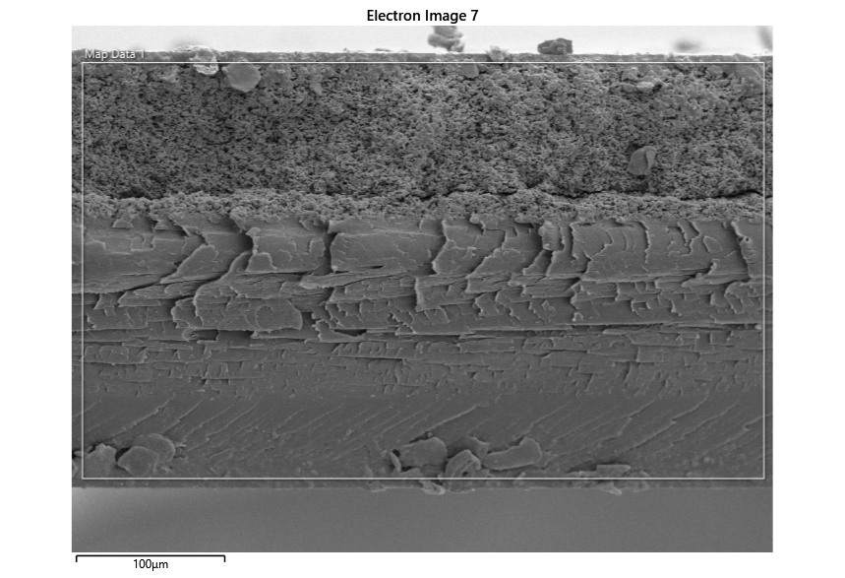

|  |  |
| --- | --- |
|  |  |

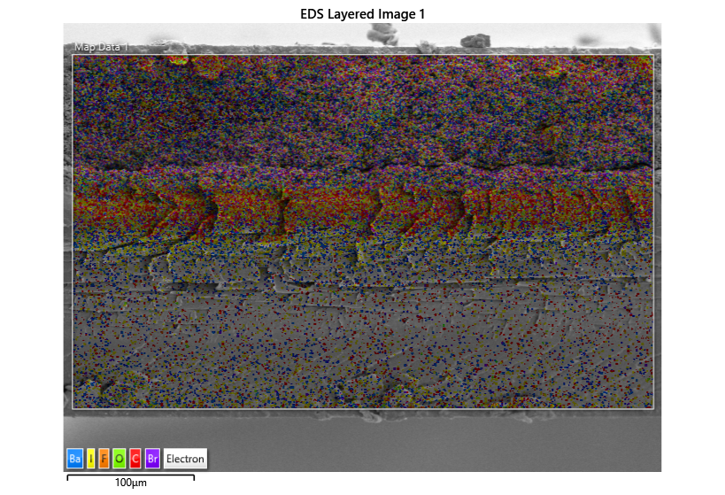

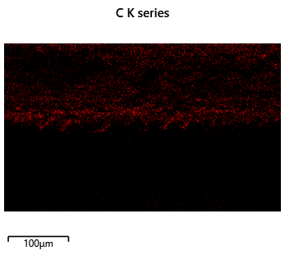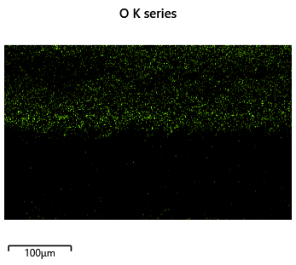

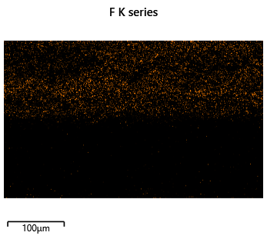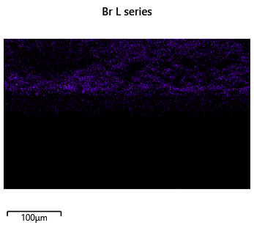

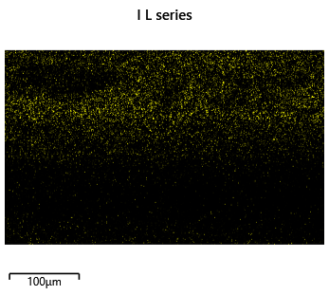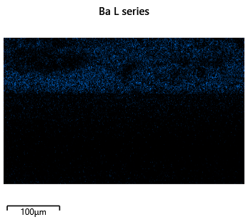

|  |  |
| --- | --- |
|  |  |

|  |  |  |
| --- | --- | --- |
| Element | Wt% | Wt% Sigma |
| C | 23.25 | 0.45 |
| F | 1.72 | 0.25 |
| Br | 16.62 | 0.36 |
| I | 6.72 | 0.36 |
| Ba | 51.69 | 0.52 |
| Total: | 100.00 |  |

|  |  |
| --- | --- |
|  |  |

|  |  |  |
| --- | --- | --- |
| Element | Wt% | Wt% Sigma |
| C | 23.25 | 0.45 |
| F | 1.72 | 0.25 |
| Br | 16.62 | 0.36 |
| I | 6.72 | 0.36 |
| Ba | 51.69 | 0.52 |
| Total: | 100.00 |  |

|  |  |
| --- | --- |
|  |  |

|  |  |  |
| --- | --- | --- |
| Element | Wt% | Wt% Sigma |
| C | 17.32 | 0.55 |
| F | 1.94 | 0.29 |
| Br | 18.27 | 0.46 |
| I | 7.40 | 0.43 |
| Ba | 55.07 | 0.64 |
| Total: | 100.00 |  |

|  |  |
| --- | --- |
|  |  |

|  |  |  |
| --- | --- | --- |
| Element | Wt% | Wt% Sigma |
| C | 28.18 | 0.76 |
| O | 4.36 | 0.61 |
| F | 2.54 | 0.62 |
| I | 6.89 | 0.76 |
| Ba | 58.03 | 1.00 |
| Total: | 100.00 |  |

|  |  |
| --- | --- |
|  |  |

|  |  |  |
| --- | --- | --- |
| Element | Wt% | Wt% Sigma |
| C | 65.91 | 1.76 |
| O | 34.09 | 1.76 |
| Total: | 100.00 |  |

|  |  |
| --- | --- |
|  |  |

|  |  |  |
| --- | --- | --- |
| Element | Wt% | Wt% Sigma |
| C | 28.40 | 0.89 |
| F | 3.12 | 0.58 |
| Al | 14.28 | 0.48 |
| I | 7.32 | 0.73 |
| Ba | 46.88 | 0.97 |
| Total: | 100.00 |  |

|  |  |
| --- | --- |
|  |  |

|  |  |  |
| --- | --- | --- |
| Element | Wt% | Wt% Sigma |
| C | 23.25 | 0.45 |
| F | 1.72 | 0.25 |
| Br | 16.62 | 0.36 |
| I | 6.72 | 0.36 |
| Ba | 51.69 | 0.52 |
| Total: | 100.00 |  |

## 1.2 FUJI SEM / EDS

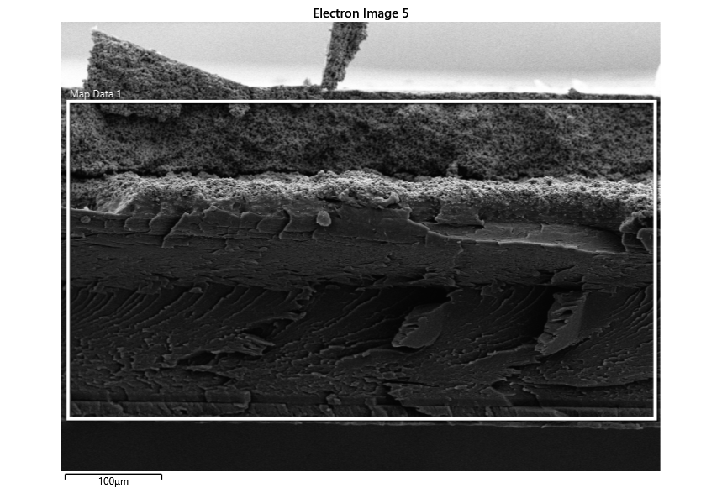

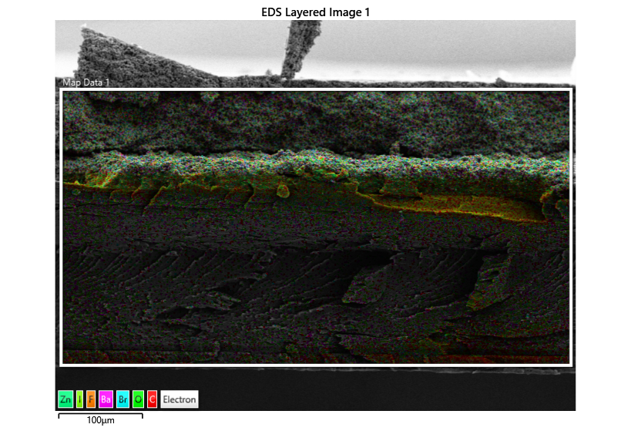

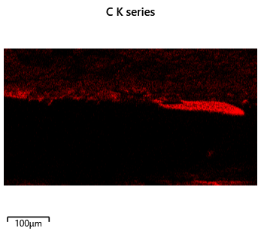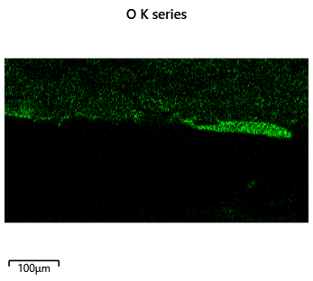

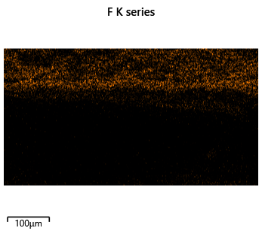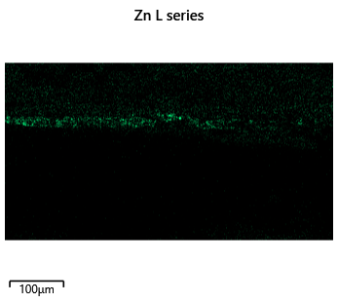

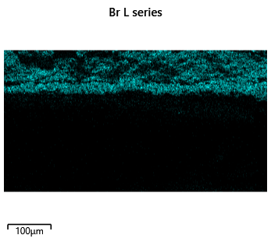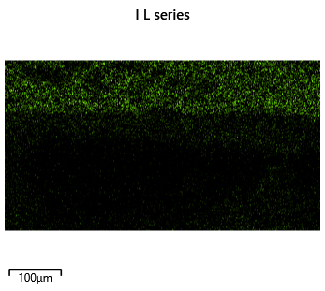

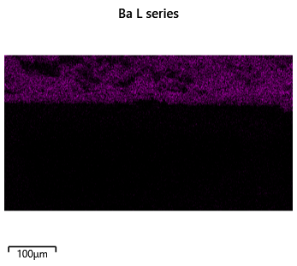

|  |  |
| --- | --- |
|  |  |

|  |  |  |
| --- | --- | --- |
| Element | Wt% | Wt% Sigma |
| C | 27.35 | 0.34 |
| O | 4.16 | 0.22 |
| F | 3.38 | 0.21 |
| Zn | 1.82 | 0.20 |
| Br | 15.45 | 0.25 |
| I | 4.37 | 0.23 |
| Ba | 43.47 | 0.38 |
| Total: | 100.00 |  |

|  |  |
| --- | --- |
|  |  |

|  |  |  |
| --- | --- | --- |
| Element | Wt% | Wt% Sigma |
| C | 13.55 | 0.33 |
| O | 1.81 | 0.19 |
| F | 3.73 | 0.21 |
| Br | 19.94 | 0.28 |
| I | 5.81 | 0.24 |
| Ba | 55.17 | 0.41 |
| Total: | 100.00 |  |

|  |  |
| --- | --- |
|  |  |

|  |  |  |
| --- | --- | --- |
| Element | Wt% | Wt% Sigma |
| C | 37.19 | 0.48 |
| O | 6.68 | 0.35 |
| F | 2.61 | 0.30 |
| Zn | 6.10 | 0.29 |
| Br | 12.74 | 0.30 |
| I | 3.33 | 0.29 |
| Ba | 31.35 | 0.45 |
| Total: | 100.00 |  |

|  |  |
| --- | --- |
|  |  |

|  |  |  |
| --- | --- | --- |
| Element | Wt% | Wt% Sigma |
| C | 94.39 | 1.07 |
| O | 5.61 | 1.07 |
| Total: | 100.00 |  |

|  |  |
| --- | --- |
|  |  |

|  |  |  |
| --- | --- | --- |
| Element | Wt% | Wt% Sigma |
| C | 62.16 | 0.57 |
| O | 37.84 | 0.57 |
| Total: | 100.00 |  |

|  |  |
| --- | --- |
|  |  |

|  |  |  |
| --- | --- | --- |
| Element | Wt% | Wt% Sigma |
| C | 55.58 | 4.18 |
| O | 13.85 | 1.96 |
| Ba | 30.58 | 4.99 |
| Total: | 100.00 |  |

|  |  |
| --- | --- |
|  |  |

|  |  |  |
| --- | --- | --- |
| Element | Wt% | Wt% Sigma |
| C | 72.04 | 1.89 |
| O | 27.96 | 1.89 |
| Total: | 100.00 |  |

|  |  |
| --- | --- |
|  |  |

|  |  |  |
| --- | --- | --- |
| Element | Wt% | Wt% Sigma |
| C | 94.39 | 1.07 |
| O | 5.61 | 1.07 |
| Total: | 100.00 |  |

|  |  |
| --- | --- |
|  |  |

|  |  |  |  |  |  |  |  |
| --- | --- | --- | --- | --- | --- | --- | --- |
| Element | Line Type | Apparent  Concentration | k Ratio | Wt% | Wt% Sigma | Standard Label | Factory Standard |
| C | K series | 0.75 | 0.00750 | 17.91 | 0.12 | C Vit | Yes |
| O | K series | 0.36 | 0.00120 | 2.71 | 0.08 | SiO2 | Yes |
| F | K series | 0.62 | 0.00122 | 2.41 | 0.08 | CaF2 | Yes |
| Zn | L series | 0.05 | 0.00054 | 0.88 | 0.06 | Zn | Yes |
| Br | L series | 0.94 | 0.00843 | 9.31 | 0.07 | KBr | Yes |
| I | L series | 0.37 | 0.00369 | 3.19 | 0.08 | I (v) | Yes |
| Ba | L series | 3.71 | 0.03473 | 29.74 | 0.13 | BaF2 | Yes |
| Au | M series | 3.63 | 0.03633 | 33.84 | 0.14 | Au | Yes |
| Total: |  |  |  | 100.00 |  |  |  |